**AFARI JESSE**

**P191301**

**JAVA LAB THREE**

**Car Demo**

**Demo One**

**class** car{

String name;

String model;

String Transmission;

**int** year;

}

**public** **class** carDemo {

**public** **static** **void** main(String[] args) {

car ca = **new** car();

ca.name="Toyota";

ca.model="Four Wheel";

ca.Transmission="Dual";

ca.year=2017;

System.***out***.println("Car Details");

System.***out***.println("Name: "+ca.name);

System.***out***.println("Model: "+ca.model);

System.***out***.println("Transmission: "+ca.Transmission);

System.***out***.println("Year: "+ca.year);

}

}

**Output**

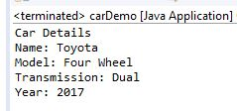

**Demo Two**

**public** **class** carDemo2 {

**public** **static** **void** main(String[] args) {

car ca = **new** car();

ca.name="Toyota";

ca.model="Four Wheel";

ca.Transmission="Dual";

ca.year=2017;

car ca2 = **new** car();

ca2.name="Benz";

ca2.model="Salon";

ca2.Transmission="Automatic";

ca2.year=2018;

System.***out***.println("Car Details");

System.***out***.println("Name: "+ca.name);

System.***out***.println("Model: "+ca.model);

System.***out***.println("Transmission: "+ca.Transmission);

System.***out***.println("Year: "+ca.year);

System.***out***.println("\nCar 2 Details");

System.***out***.println("Name: "+ca2.name);

System.***out***.println("Model: "+ca2.model);

System.***out***.println("Transmission: "+ca2.Transmission);

System.***out***.println("Year: "+ca2.year);

}

}

**Output**

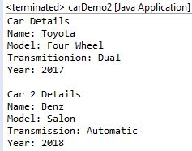

**Demo Three**

**class** carinfo{

String name;

String model;

String Transmission;

**int** year;

**void** cardetails() {

System.***out***.println("Car Details");

System.***out***.println("Name: "+name);

System.***out***.println("Model: "+model);

System.***out***.println("Transmission: "+Transmission);

System.***out***.println("Year: "+year);

}

}

**public** **class** carDemo3 {

**public** **static** **void** main(String[] args) {

carinfo ca = **new** carinfo();

ca.name="Toyota";

ca.model="Four Wheel";

ca.Transmission="Dual";

ca.year=2017;

ca.cardetails();

}

}

**Output**

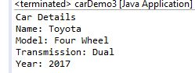

**Demo Four**

**class** carinfo1{

String name;

String model;

String Transmission;

**int** year;

**double** rentprice,totalrent;

**int** days;

**void** rentdetails() {

System.***out***.println("Car Rent Details");

System.***out***.println("Name: "+name);

System.***out***.println("Model: "+model);

System.***out***.println("Transmission: "+Transmission);

System.***out***.println("Year: "+year);

System.***out***.println("Days: "+days);

System.***out***.println("Rent Per day: "+rentprice);

}

Double total() {

totalrent=rentprice*days;

**return** totalrent;}}

**public** **class** carDemo4 {

**public** **static** **void** main(String[] args) {

**double** t;

carinfo1 ca = **new** carinfo1();

ca.name="Toyota";

ca.model="Four Wheel";

ca.Transmission="Dual";

ca.year=2017;

ca.days=10;

ca.rentprice=100.50;

ca.rentdetails();

t=ca.total();

System.***out***.println("Total Rent: "+t);

}

}

**Output**

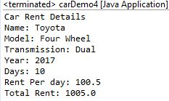

**Customer Demo**

**Demo One**

**import** java.util.*;

**class** customerI{

String name;

**int** age;

**double** payment;

}

**public** **class** Customer {

**public** **static** **void** main(String[] args) {

customerI cus = **new** customerI();

cus.name="Jesse";

cus.age=20;

cus.payment=10000.4;

System.***out***.println("Customer Details: ");

System.***out***.println("\nName: "+cus.name);

System.***out***.println("Age: "+cus.age);

System.***out***.println("Payment: "+cus.payment);

}

}

**Output**

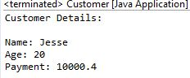

**Demo Two**

**public** **class** CustomerDemo2 {

**public** **static** **void** main(String[] args) {

customerI cus = **new** customerI();

customerI cus2=**new** customerI();

cus.name="Jesse";

cus.age=20;

cus.payment=10000.4;

cus2.name="Jason";

cus2.age=25;

cus2.payment=20000.4;

System.***out***.println("Customer Details One: ");

System.***out***.println("\nName: "+cus.name);

System.***out***.println("Age: "+cus.age);

System.***out***.println("Payment: "+cus.payment);

System.***out***.println("Customer Details Two: ");

System.***out***.println("\nName: "+cus2.name);

System.***out***.println("Age: "+cus2.age);

System.***out***.println("Payment: "+cus2.payment);

}

}

**Output**

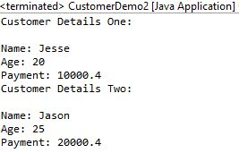

**Demo Three**

**class** customerInfo{

String name;

**int** age;

**double** payment;

**void** details() {

System.***out***.println("Customer Details One: ");

System.***out***.println(name);

System.***out***.println(age);

System.***out***.println(payment);

}

}

**public** **class** CustomerDemo3 {

**public** **static** **void** main(String[] args) {

customerInfo cus = **new** customerInfo();

customerI cus2=**new** customerI();

cus.name="Jesse";

cus.age=20;

cus.payment=10000.4;

cus.details();

}

}

**Output**

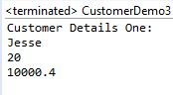

**Demo Four**

**class** customerGoods{

String name,item1,item2;

**int** age;

**double** payment,totalprice,item1p,item2p;

**void** details() {

System.***out***.println("Customer Details One: ");

System.***out***.println(name);

System.***out***.println(age);

System.***out***.println(item1);

System.***out***.println(item2);

}

Double total() {

totalprice=item1p+item2p;

**return** totalprice;}}

**public** **class** CustomerDemo4 {

**public** **static** **void** main(String[] args) {

**double** t;

customerGoods cus = **new** customerGoods();

cus.name="Jesse";

cus.age=20;

cus.item1="Tomatoes";

cus.item2="Fish";

cus.item1p=50.50;

cus.item2p=60.5;

cus.details();

t=cus.total();

System.***out***.println("Total Purchase: "+t);

}

}

**Output**

